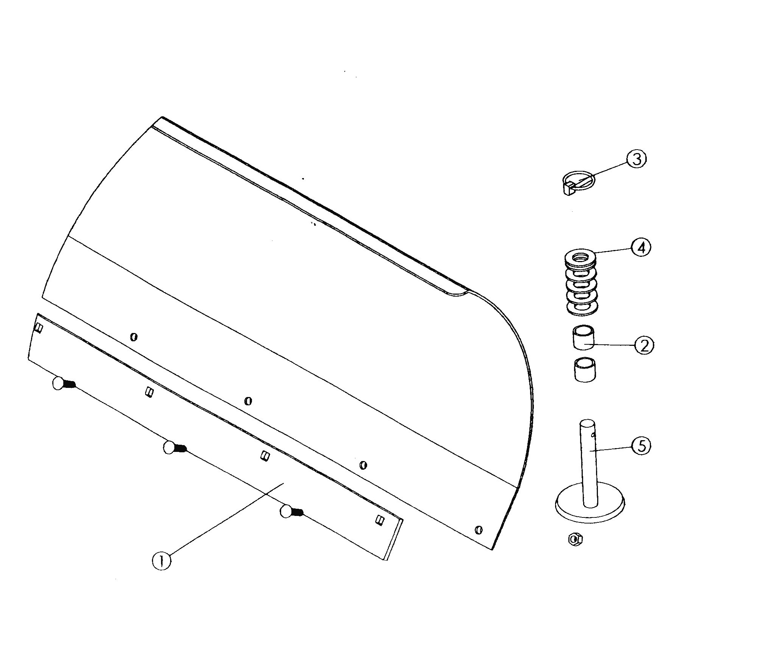
Blade Hardware
ITEM NO. | QTY | DESCRIPTION
1 | 1 | 60’’ Wear Bar
2 | 4 | 5/8’’ x 1’’ Spacer
3 | 2 | 3/16’’ x 1 1/2’’ Quick Pin
4 | 12 | 5/8’’ SAE Flat Washer
5 | 2 | Heavy-Duty Skid

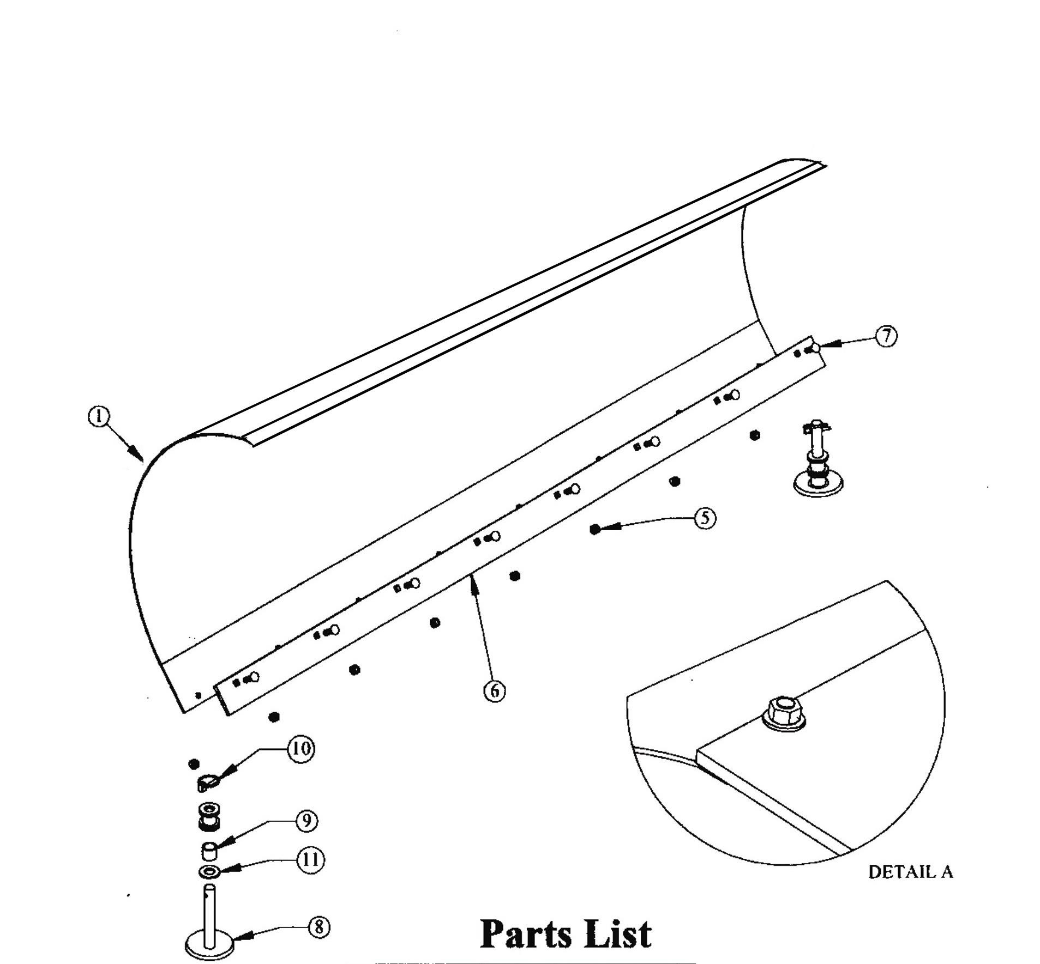
ITEM NO. | QTY | DESCRIPTION
1 | 1 | Blade, 60’’ State Plow
5 | 9 | 3/8’’ Nylock Nut
6 | 1 | 60’’ Wear Bar
7 | 9 | 3/8’’ x 1’’ Carriage Bolt
8 | 2 | Heavy-Duty Skid
9 | 4 | 5/8’’ x 1’’ Spacer
10 | 2 | 3/16’’ x 1 1/2’’ Quick Pin
11 | 12 | 5/8’’ x SAE Flat Washer

Assembly Instructions
1. The Top Flap is shipped unassembled in the box with your new Bronco® plow.
The Top Flap needs to be bolted to the top of the Blade using the supplied 5/16’’ x
3/4’’ carriage bolts and flat washers.
2. Place the Top Flap on top of the Blade, pushing the 5/16’’x 3/4’’ carriage bolts up from the inside of Blade through the Top Flap. The place the flat washers over the carriage bolts and install the Nylock nuts. Be careful not to over tighten the Nylock nuts. Tighten to where the top of the Nylock nut is flush with the carriage bolt. (See Drawing above, Detail A)

